**Geometric optics outline and materials  
Catherine Crouch, Swarthmore College**

I. How light interacts with objects  
Overall motivation: Forming images with light is one of the primary ways we perceive the world around us; this unit enables us to understand how our eyes do this both on their own and aided by instruments.

1. Ray model of light: light travels in straight lines  
   a. shadows  
   b. image formation with pinholes (invertebrate vision)
2. How light interacts with objects  
   a. reflection, transmission, and absorption  
   b. image formation with plane mirrors; introduce virtual images[1]  
   b. refraction/Snell’s Law  
   c. total internal reflection (optical fibers/ endoscopes)

II. Collecting light with lenses to form images

1. Real images with single lenses  
   a. Focusing light with converging lenses  
   b. Forming real images with single converging lenses (including lens equation)   
   c. How focal length of converging lens depends (qualitatively) on shape
2. Human vision  
   *Key pedagogical choice here: normally physics considers fixed focal length lenses with adjustable object and image position; in normal vision the object and image position are fixed and the focal length adjusts. Need to help students consider this different paradigm.*  
   a. eye has fixed position retina, adjustable focal length lens (in addition to fixed focal length cornea): conceptual questions  
   b. Lens equation at boundary between media; calculations
3. Virtual images with single lenses  
   a. magnifying glass   
   b. diverging lenses
4. Lens combinations (corrective lenses, microscope): image formed by first lens serves as object for second lens  
   a. Looking through a magnifying glass/correcting farsightedness (presbyopia)[2]  
   b. Correcting nearsightedness  
   c. Microscope forming real image on CCD detector (covered in lab/homework)  
   d. Microscope forming virtual image to be viewed by an observer (covered in lab/homework)

Geometric optics is the first subject of the semester, for multiple reasons:

• The vision-based biological contexts are familiar from everyday experience and can be directly observed both in real life and in the laboratory, so it combines the value of biological context with the value of connecting to real-life experience.

• Students find geometric optics very engaging and motivating (presumably partly because of the reasons above).

• We return to wave optics at the end of the semester after students have studied electricity and magnetism, so optics serves to hold the whole semester together.

• It is difficult at Swarthmore to begin the laboratories the first week of class due to our system for registering students for classes, so our labs generally cover material after it has been discussed in class. Putting optics at the beginning of the semester therefore allows us to offer more optics labs than if optics is taught at the end of the semester.

One difference between geometric optics and the rest of the material is that at least in the past, I have not seen obvious opportunities for approximations and estimations; all of the calculations are done exactly. Consequently, the role of modeling is much less apparent than in the E&M portion of the semester. The one type of modeling done is to treat all lenses as thin lenses, but as we never discuss methods for exact treatment of thick lenses, this modeling is probably not very apparent to the students. **Conceptual questions and in-class problems (homework and laboratories provided separately)**

Each of the following questions and problems is provided on its own page because I project these single pages for the class to see. In many cases there is also a page showing the solution if there is an image involved.

I typically teach this material in two 90-minute classes per week. Along with a roughly 25-minute general introduction to the course that happens in the first class, in the past I have spent the first week on all of item I in the outline and have also discussed image formation with curved mirrors qualitatively. In the future I intend to omit image formation with curved mirrors which will give more time for the later material.

The remaining material (item II of the outline) requires a little more than another week.

After class, these ideas are further explored on homework and in problem-solving laboratories. The laboratories include preparatory assignments that function as part of the homework.An image of a bright arrow is formed on a screen by a pinhole.

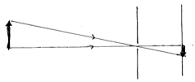

To increase the size of the image, you should:

1. move the pinhole closer to the object (arrow).

2. move the pinhole closer to the image.

3. move the pinhole up.

4. move the pinhole down.

5. make the pinhole bigger.

6. make the pinhole smaller.

Solution: show ray tracing   
To make the image larger, move the pinhole closer (keeping the screen in the same place):



becomes

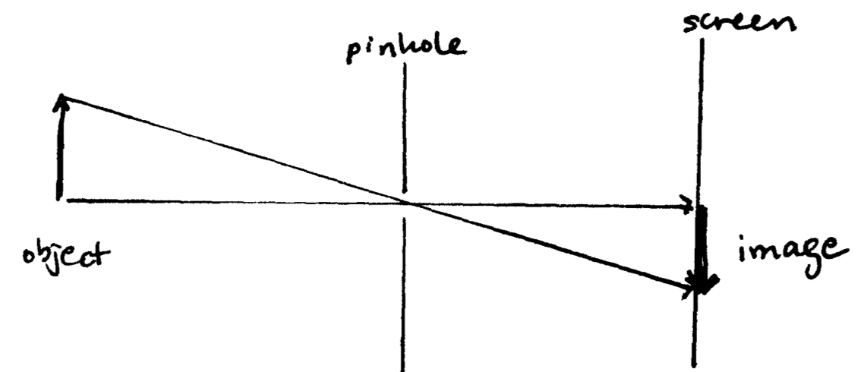

A chambered nautilus has eyes consisting of 1-mm holes in front of a small region of light-sensitive tissue. Suppose the light-sensitive tissue is a circular region 1 cm in diameter. If a complete image of a 1-m tall seaweed 10 m in front of the nautilus will be 1 mm tall on the light-sensitive tissue, where is the pinhole relative to the light-sensitive tissue?

Figure for use in showing how to find answer (I would draw this on the board)  
A chambered nautilus has eyes consisting of 1-mm holes in front of a small region of light-sensitive tissue. Suppose the light-sensitive tissue is a circular region 1 cm in diameter. If a complete image of a 1-m tall seaweed 10 m in front of the nautilus will be 1 mm tall on the light-sensitive tissue, where is the pinhole relative to the light-sensitive tissue?

pinhole calc

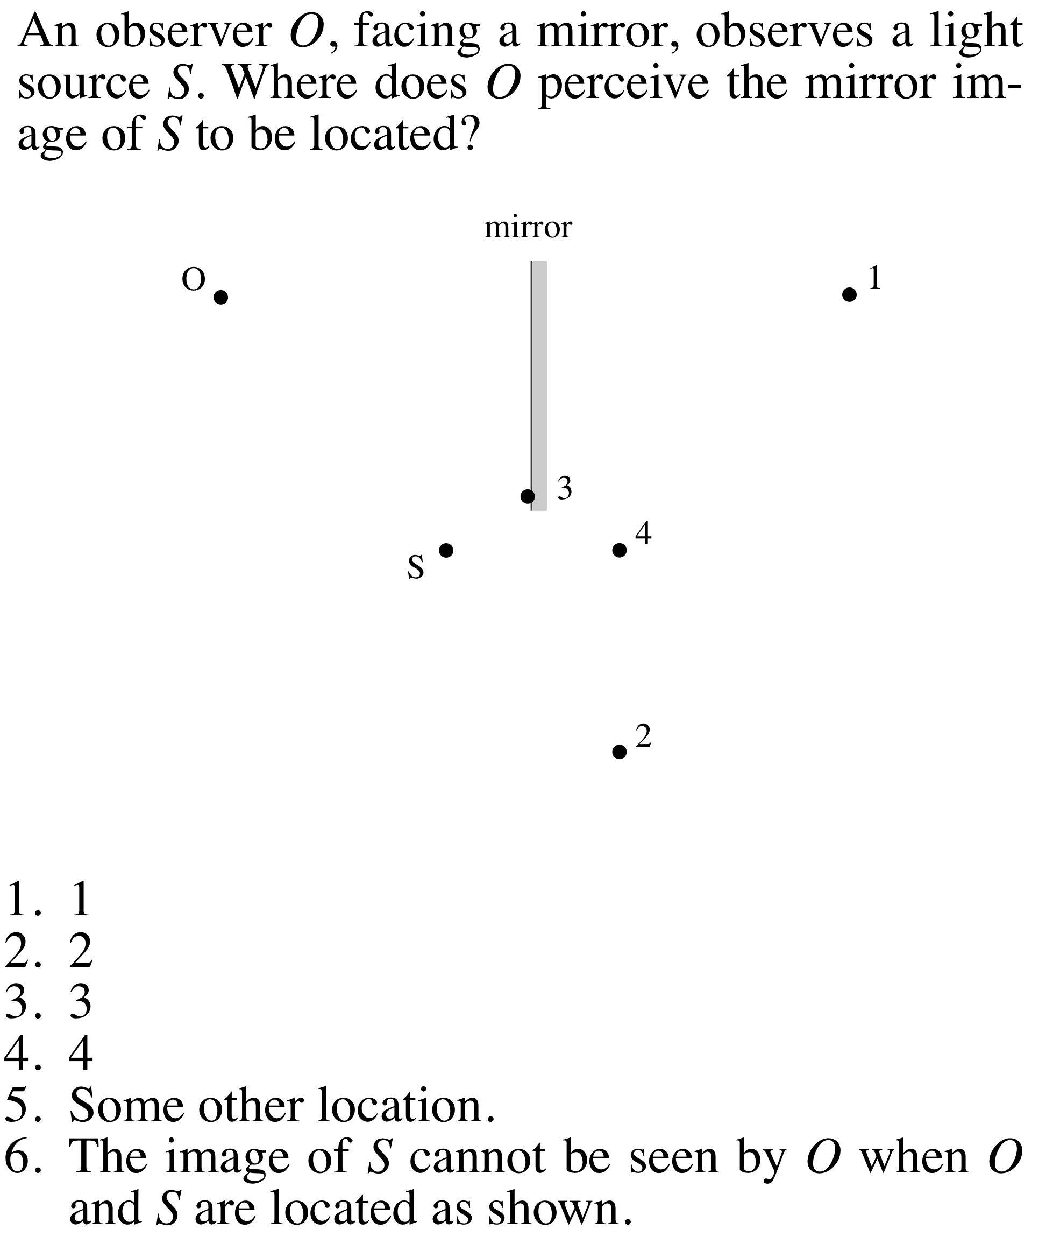

from Mazur, *Peer Instruction User’s Manual*You are standing in front of a mirror. If the mirror is flat on the wall, what minimum length must the mirror be in order for you to see your entire body in the mirror?

1. About your full height.
2. About three quarters of your height.
3. About half your height.
4. About one quarter of your height.

A fish swims below the surface of the water. Suppose an observer looks at the fish from directly above. Light rays leave point *P* and travel from the water into the air and to the observer’s eye. Those light rays appear to come from

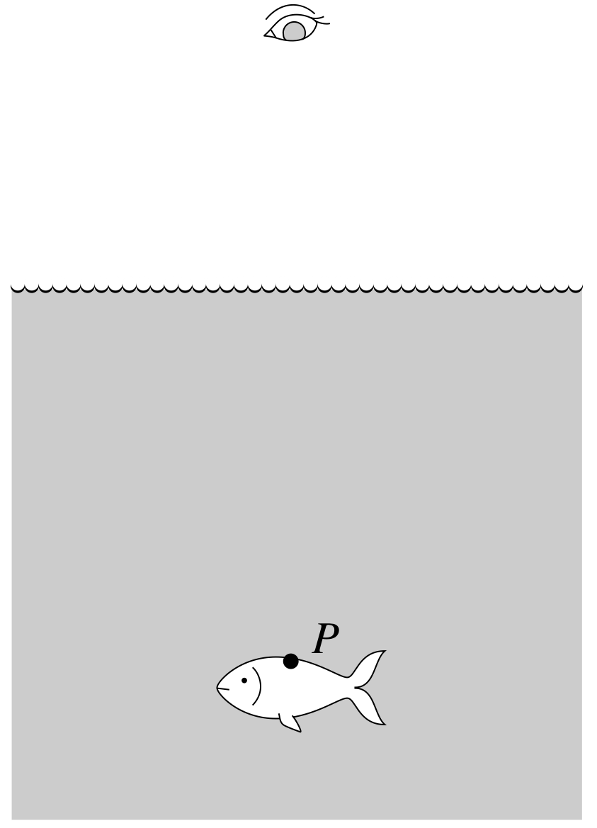

1. Point P.

2. Somewhere above point P.

3. Somewhere below point P.

4. Need more information to answer.

from Mazur, *Peer Instruction User’s Manual*2. Somewhere above point P.

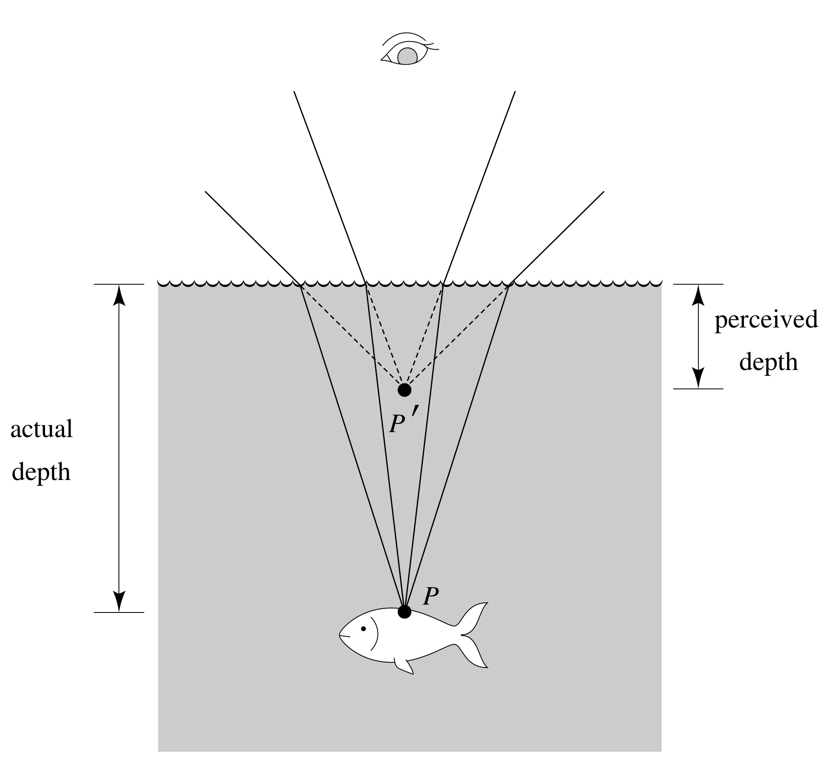

from Mazur, *Peer Instruction User’s Manual*You shine a laser pointer into a filled aquarium from above; the laser beam strikes the surface of the water at 40° from the normal and then reaches the glass side wall of the aquarium. Does the laser beam exit that wall of the aquarium, and if so, at what angle to the wall?

A lens is used to image an object onto a screen.

If the top half of the lens is covered,

1. the top half of the image disappears.

2. the bottom half of the image disappears.

3. the entire image disappears.

4. the image becomes blurred.

5. the image becomes fainter.

A converging lens is used in a projector to form an image of a bright light source on a screen.

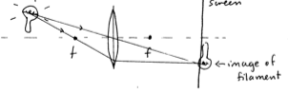

If the screen is moved toward the lens, to keep the image in focus, the source should be moved

1. Closer to the lens.
2. Farther from the lens.
3. It doesn’t need to be moved (the image will still be in focus on the screen).
4. Need more information to answer.

from Mazur, *Peer Instruction User’s Manual*Figure for use in showing how to find answer (I would draw this on the board)  
2: The source should be moved farther from the lens.

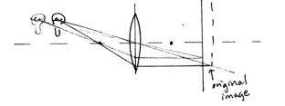

If an object is much farther away than the focal length of a converging lens, roughly where does the image form?

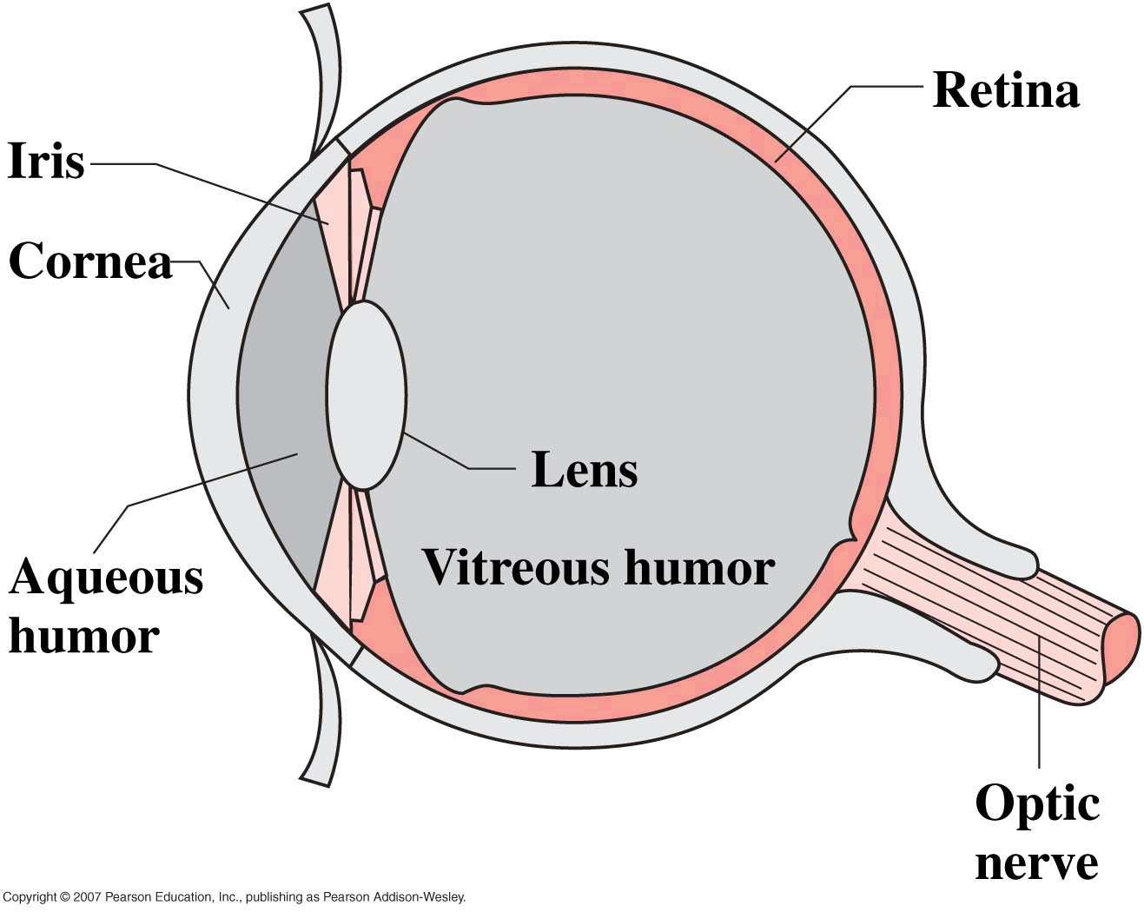 Wolfson Fig. 31.27

Is the image formed by your eye on your retina right side up or upside down?

1. Right side up

2. Upside down

Figure for use in showing how to find answer (projected)

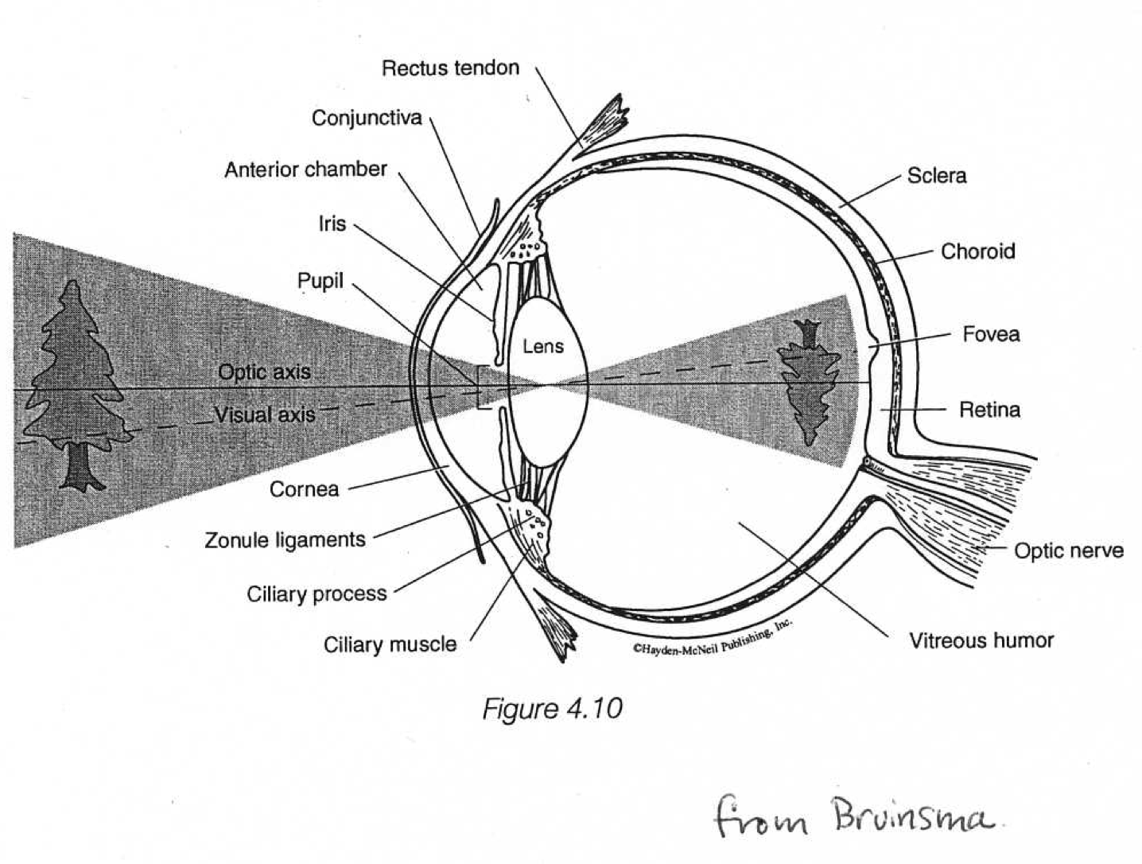Lens equation for a thin lens at the boundary between two media of different refractive index:

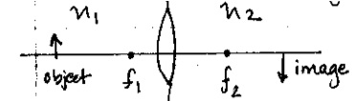



You are looking at a plant that is 10 cm tall and 0.75 m away from your face. Your retina is 23 mm from your eye’s lens. What is the focal length of your eye’s lens and how big is the image of the plant? (Treat the cornea and lens as a single lens as always. The eye’s contents have neye = 1.34.)

You are in a garden looking at a nearby flower. If you then turn your gaze to a more distant tree, how does the focal length of your eye’s lens change, if at all?

1. The focal length increases.

2. The focal length decreases.

3. The focal length remains the same.

4. Need more information.

You are in a garden looking at a nearby flower. If you then turn your gaze to a more distant tree, how does the shape of your eye’s lens change, if at all?

1. The lens becomes rounder (more curved).

2. The lens becomes flatter.

3. The lens remains the same shape.

4. Need more information.

You are outdoors using a magnifying glass to examine an interesting insect on a sunny day. You notice that if you hold a piece of paper 15.0 cm underneath the magnifying glass and let the sun’s light fall on the magnifying glass, it makes a bright spot. Where should you hold the lens to create an image of the insect magnified to three times its actual size?

You want to use a lens to cast a magnified image of a candle flame on the wall of your dorm room so that you can see better what the flame looks like. The candle and the wall are 70 cm apart. You borrowed a 15-cm focal length converging lens and a -15-cm focal length diverging lens from the physics labs. Which lens should you use, and where should you put it?

You are viewing an insect with 3x magnification with your magnifying glass as in the previous problem. If the focal length of your eye’s lens (in your eye) is 21.4 mm when you are looking through the magnifying glass, and your retina is 23 mm from your eye’s lens, how close is your eye’s lens to the magnifying glass?

You hold a 10 cm focal length lens 12 cm from your page of Physics 4L notes and look through it. (Try it!) If your face is 20 cm from the lens (with the lens between your notes and your face), and you have normal (or corrected) vision, explain why you can’t see anything through the lens.

A farsighted person has difficulty focusing on objects that are close by. Corrective lenses for a farsighted person should create images of nearby objects that are

1. Bigger than the object.

2. Smaller than the object.

3. Closer to the person than the object.

4. Farther from the person than the object.

Is the retina in a nearsighted person too close to the lens or too far from the lens?

1. Too close.

2. Too far.

Erik Smith (Physics 4L Science Associate) cannot see clearly beyond 80 cm. Prescribe a lens power that will allow him to see distant objects clearly.

Microscope homework problem:

You are using a microscope that produces an image recorded by the light-sensitive detector of a CCD camera. The microscope has a 40x objective lens and a second +10 cm focal length lens giving 2x additional magnification. The figure showing the optical arrangement is **not** to scale.

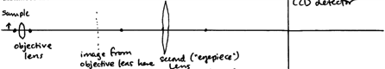

(a) Is the image on the detector real or virtual? Upright or inverted (relative to the sample)?

(b) If the sample is 2.0 mm from the objective when the final image is in focus, how far is the detector from the objective lens?

1. In the past I have taught image formation with curved mirrors qualitatively here, just using ray tracing, but I don’t think it’s useful enough to include and it takes time, so I plan to leave it out in the future.
2. In class we just briefly discuss that correcting farsightedness requires displacing images of near objects farther away, which is exactly like using a magnifying glass, and then students do a problem on the homework.