Introductory electrostatics problem for physics for life science students  
Catherine Crouch, Swarthmore College

The phosopholipid molecule PIP2 (phosphatidylinositol 4,5-bisphosphate) is an important constituent of eukaryotic cell membranes. Its hydrophilic head group has a greater negative charge (typically -4e under physiological pH) than most of the other phospholipids present in eukaryotic cell membranes. PIP2 makes up only a small fraction of the membrane (typically ~1 mol%), but in spite of this low concentration, it is known to form clusters with multiple PIP2 molecules that are thought to be important in cell signaling. It is an area of active research to understand the basis of this cluster formation.

Recent research (Wang, Janmey, and coworkers) provides support for an electrostatic mechanism for this clustering, in which Ca2+ ions provide an attractive interaction holding together the PIP2 molecules. The detailed structure of how Ca2+ ions and PIP2 molecules are arranged in these clusters is not yet known. In this problem we consider a highly simplified model simply to give a feel for how these interactions work.

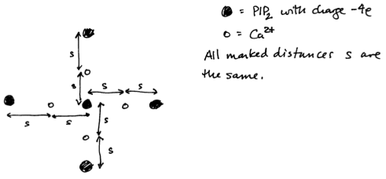A simplified model of such a cluster consists of five PIP2 molecules, each with a headgroup charge of -4e, and four Ca2+ ions arranged as shown.

(a) Considering just the electrostatic forces present, does this arrangement attract the PIP2 molecules toward the center? Would your answer change if the Ca2+ was replaced by Na+?

(b) You should have found in part (a) that indeed the electrostatic forces are attractive; thus if only these forces were present, this arrangement would tend to collapse inward. Qualitatively discuss what resists inward collapse of this arrangement.

*Solution*:

1. Calculation provided as a separate PDF file. The result is that the force is attractive with divalent cations for any value of the separation *s*, but not attractive with monovalent cations for any value of *s*.
2. The model calculation in (a), by using Coulomb’s Law, treats the Ca2+ ions and PIP2 as point particles. In fact the charged headgroups of the PIP2 molecules are sizable and attached to lipid tails that must pack together in the membrane, and the Ca2+ ions are surrounded by shells of water molecules, so they cannot approach too closely before steric repulsive interactions offset the electrostatic attraction.